Parker Goodwin

Dr. Cheney

DGM 2120

18 January 2016

Unit 2 – Planning A Website

**Site Goal –** Adventure Developers is a company for any outdoor product company who is looking to have their product professionally reviewed and evaluated for the sole purpose of helping their product become better. The site will have information behind who the company is and what they namely do for their clients. The client page will describe who some of their big name brands are and what AD has done for them and their products, testimonials will also be there. Their will be pricing in the development section, along with the various options they offer their clients. The About page will describe the vision and the goal of the company. The Contact page will give them the necessary information to get in touch via email.

**Audience –** The audience will be any brands that are in the outdoor market selling their product to retail stores. AD helps them develop and test their product before any of it is released before it is released to the general public.

**Desktop and Phone Wireframe –** What the site looks like on both desktop and mobile views.

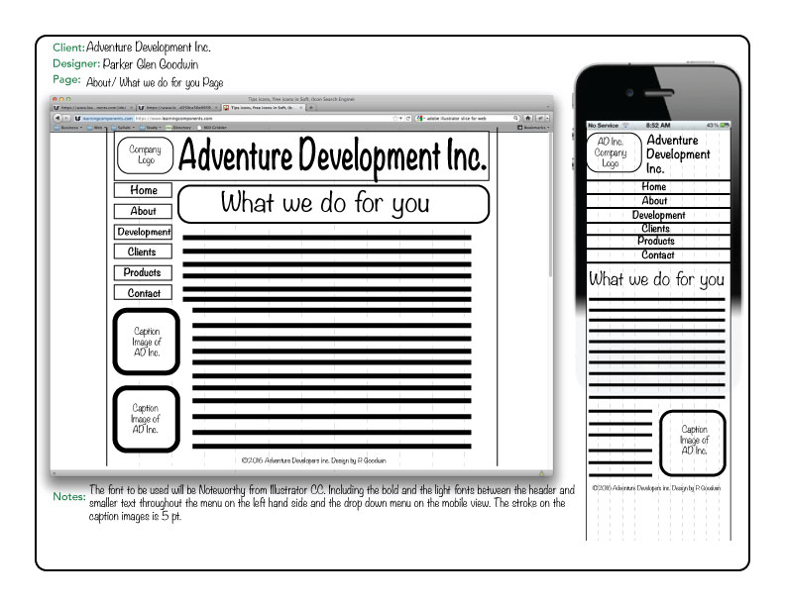

**Site Map—**All of the pages are accessible from the home page, there is going to be no links between the about, clients and contact page. Each of those are going to be built solely to show the user what the company does, who we have done work for and how to get in touch. I am going to link the development and product pages to show the user the differing packages AD offers for specific types of development.

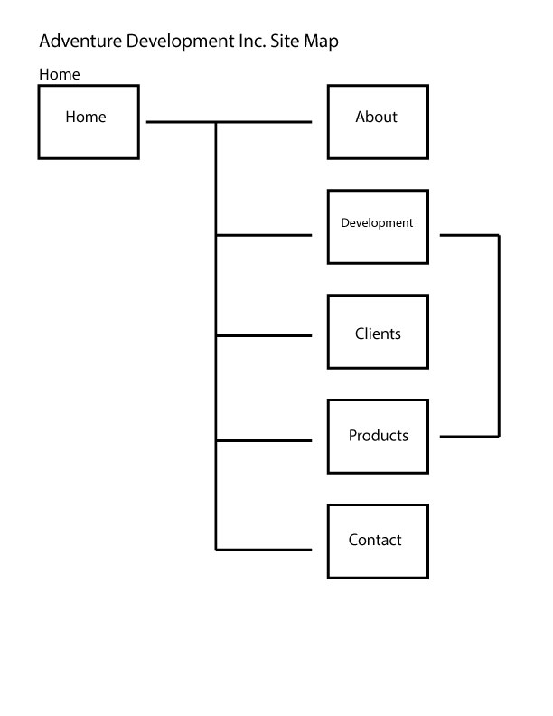

**Kuler Color Scheme** – These colors fit the market of this company, they seem organic and feel natural, which will allow the site to stay simple with presentation.

